CAN-DO RESEARCH LAB | KNUST DEPARTMENT OF COMPUTER SCIENCE
PHASE 1 · STEP 1.2 — TESTBED SUBMISSION
ML RESULTS AND ANALYSIS SECTION — DRAFT 0 TEMPLATE

Part 0 — Passport Check Block
Field | Entry | Field | Entry
Student name | Bartimeus Manuel Nii Osabu; Oti Wisdom Boakye; Antwi Jeffrey Twum; Manu Richeal Pokuah; Karikari David Kweku (Group 3) | Student ID | 3382422; 3419922; 3372922; 3398922; 3394522
Supervisor | Dr. Eric Opoku Osei | Submission round | R1
Folder | ML | Date submitted | 7 August 2026
Model status | ENGINEERED (predictive learner applied as published) | F/M/R/S operation | F — Fabricate (SHAPtoSMS)
Dataset strategy | TRAINING-ONLY-AUG | Claim tier ceiling | Tier 1
Primary metric | AUC-PR (RPS@1/@2 for SHAPtoSMS) | Statistical test | McNemar exact + paired bootstrap 95% CI; BH FDR
Runs x folds | 5 runs (seeds) x 5 folds (CV diagnostic) | Random seed(s) | 42, 123, 777, 2024, 9999
Target journal (primary) | Computers & Education: Artificial Intelligence | Format family | Elsevier
Word budget (Results) | 1,200-2,200 (Elsevier) | Citation style | APA (7th ed.)
Methods Passport signed | YES | Methods round | R1

3. Results and Analysis
This section reports measured quantities only. Interpretation, comparison with prior literature, and causal accounts are deferred to the Discussion.

R1. Evaluation Corpus and Partition Summary
The held-out evaluation partition comprised 248 real student-year records, of which 241 were non-dropout and 7 were dropout, a positive rate of 2.82% (7/248). The partition was the temporal hold-out defined in Methods M9: all records with academic_year >= 2025 formed the test set. It comprised 100% real data with no synthetic or resampled instances. Two separate pieces of evidence support that statement rather than one. First, the load-time provenance guard described in Methods M10 executed on every construction of the partition and recorded "NF-1 GUARD: test partition n=248 | synthetic rows=0 | real rows=248 | positives=7 (2.82%) — PASS" in the run log; the guard is built to be falsifiable — the partition is formed from the pooled frame, and a negative control confirms the guard raises when a synthetic record is injected into the test period. Second, the real-only-subset re-scoring is reported here rather than retired as redundant: scoring the real-only subset independently returns n = 248, base rate 0.0282, AUC-PR 0.1033, AUC-ROC 0.5969, precision 0.0351 and recall 0.2857, identical in every digit to the full partition, because removing synthetic records from this partition removes 0 records. The identity is the evidence, and it is computed rather than asserted. Trainable models were evaluated across five independent seeds {42, 123, 777, 2024, 9999}, and a separate stratified five-fold cross-validation on the train+validation pool was run as a stability diagnostic, matching Methods M14 (five runs x five folds); a ten-seed stability arm is reported separately in R3. The train+validation pool held 530 records (180 real + 350 synthetic; 62 positive, 11.7%, a 7.55:1 negative-to-positive ratio); the synthetic supplement was confined to that pool and served an augmentation-only role, while the evaluation partition was entirely real. All figures in this section trace to the single locked run described in Methods M21, in which the synthetic supplement is generated under a fixed seed and committed as a data artefact rather than regenerated at run time; the number reconciliation is given in R11. The corpus is drawn from 4 sites (Methods M3, Table 1b), and the evaluation partition is unevenly distributed across them: SCH01 145 records and 5 events; SCH02 59 records and 2 events; SCH03 17 records and 0 events; SCH04 27 records and 0 events. 2 of the 4 sites carry no dropout event in the test period at all, which is what limits the leave-one-site-out analysis reported in R8. The evaluation protocol follows the TRAINING-ONLY AUGMENTATION design declared in Methods M10, and all reported claims are constrained to the Tier 1 ceiling.

R2. Baseline versus Proposed Performance — Main Results
Table 3 reports held-out test-set performance as mean ± standard deviation across the five seeds; the primary metric is AUC-PR, named as primary in Methods M15. The proposed XGBoost recorded AUC-PR 0.1167 ± 0.0444, an absolute delta of -0.0302 against the default XGBoost (0.1469 ± 0.0896); this delta is a difference of five-seed means. Among all comparators TabTransformer recorded the highest AUC-PR (0.2387 ± 0.0559) and the Attendance ranker the next highest (0.1284), both exceeding the proposed model on the primary metric; the Decision Tree recorded 0.0774 ± 0.0205. On recall, the proposed model recorded 0.4000 ± 0.1069, which is the higher of the two XGBoost variants (default: 0.3714 ± 0.1143); TabTransformer recorded higher recall still (0.5143 ± 0.0700), and the binary Attendance rule the highest of all (0.7143 at its single operating point). The earlier claim that the proposed model recorded the highest recall of the probabilistic models trained across seeds is withdrawn: it contradicted the table it accompanied. The paired bootstrap 95% confidence interval on the AUC-PR difference between the proposed and default models (10,000 resamples; the method declared in Methods M16) was [-0.0409, 0.1227], with a mean delta of 0.0170 — a seed-42 resampling quantity, not a seed-average one. The two figures carry opposite signs because they are computed in different reference frames, not because either is in error: -0.0302 is the difference of the five-seed mean AUC-PR values, while +0.0170 is the mean of the paired per-resample differences within the single seed-42 run. R11 assigns each figure to its frame. Figure 4 plots the ROC and precision–recall operating characteristics for the four probabilistic models on the same axes.
Table 3. Held-out test-set performance (248 real records, 7 dropout), mean ± SD across five seeds. AUC-PR is the primary metric; the Δ column is the absolute difference in AUC-PR from the default XGBoost. The status-quo attendance baseline is reported as two rows because it requires two different score vectors (Methods M11): the deployed binary rule and a univariate continuous ranker. † Single seed-42 run (no ± SD), reported for completeness; calibration did not improve the primary metric (R10). ‡ The binary rule yields one operating point, so its AUC-ROC and AUC-PR are SINGLE-POINT values computed from that point (flagged 56/248; TP 5, FP 51, FPR 0.2116), not threshold-free areas. § The continuous ranker scores 1 − scaled(attendance_rate); threshold-dependent metrics are not defined for it, as it prescribes no decision rule. ¶ Seed-42 single-run reference for the proposed model: AUC-PR 0.1033, AUC-ROC 0.5969 — the anchor against which the isotonic row is compared, so that comparison sits in a single reference frame.
Model | AUC-PR (primary) | Δ AUC-PR vs default | AUC-ROC | F2 | Macro-F1 | Precision | Recall
Proposed XGBoost ¶ | 0.1167 ± 0.0444 | -0.0302 | 0.6182 ± 0.0754 | 0.1532 ± 0.0662 | 0.4478 ± 0.0675 | 0.0492 ± 0.0322 | 0.4000 ± 0.1069
Proposed XGBoost — isotonic-calibrated † | 0.0933 | -0.0100 (vs seed-42 uncalibrated ¶) | 0.6165 | 0.1220 | 0.4673 | 0.0370 | 0.2857
Default XGBoost | 0.1469 ± 0.0896 | 0.0000 | 0.6816 ± 0.0422 | 0.1747 ± 0.0422 | 0.4947 ± 0.0241 | 0.0586 ± 0.0173 | 0.3714 ± 0.1143
TabTransformer | 0.2387 ± 0.0559 | +0.0918 | 0.7248 ± 0.0409 | 0.2572 ± 0.0527 | 0.5254 ± 0.0383 | 0.0901 ± 0.0300 | 0.5143 ± 0.0700
Decision Tree | 0.0774 ± 0.0205 | -0.0695 | 0.5914 ± 0.0448 | 0.1869 ± 0.0560 | 0.5186 ± 0.0402 | 0.0763 ± 0.0309 | 0.3143 ± 0.0571
Attendance rule (binary, threshold 0.70) ‡ | 0.0718 (single point) | not comparable ‡ | 0.7513 (single point) | 0.2976 | 0.5182 | 0.0893 | 0.7143
Attendance ranker (continuous, univariate) § | 0.1284 | -0.0185 | 0.8678 | n/a | n/a | n/a | n/a
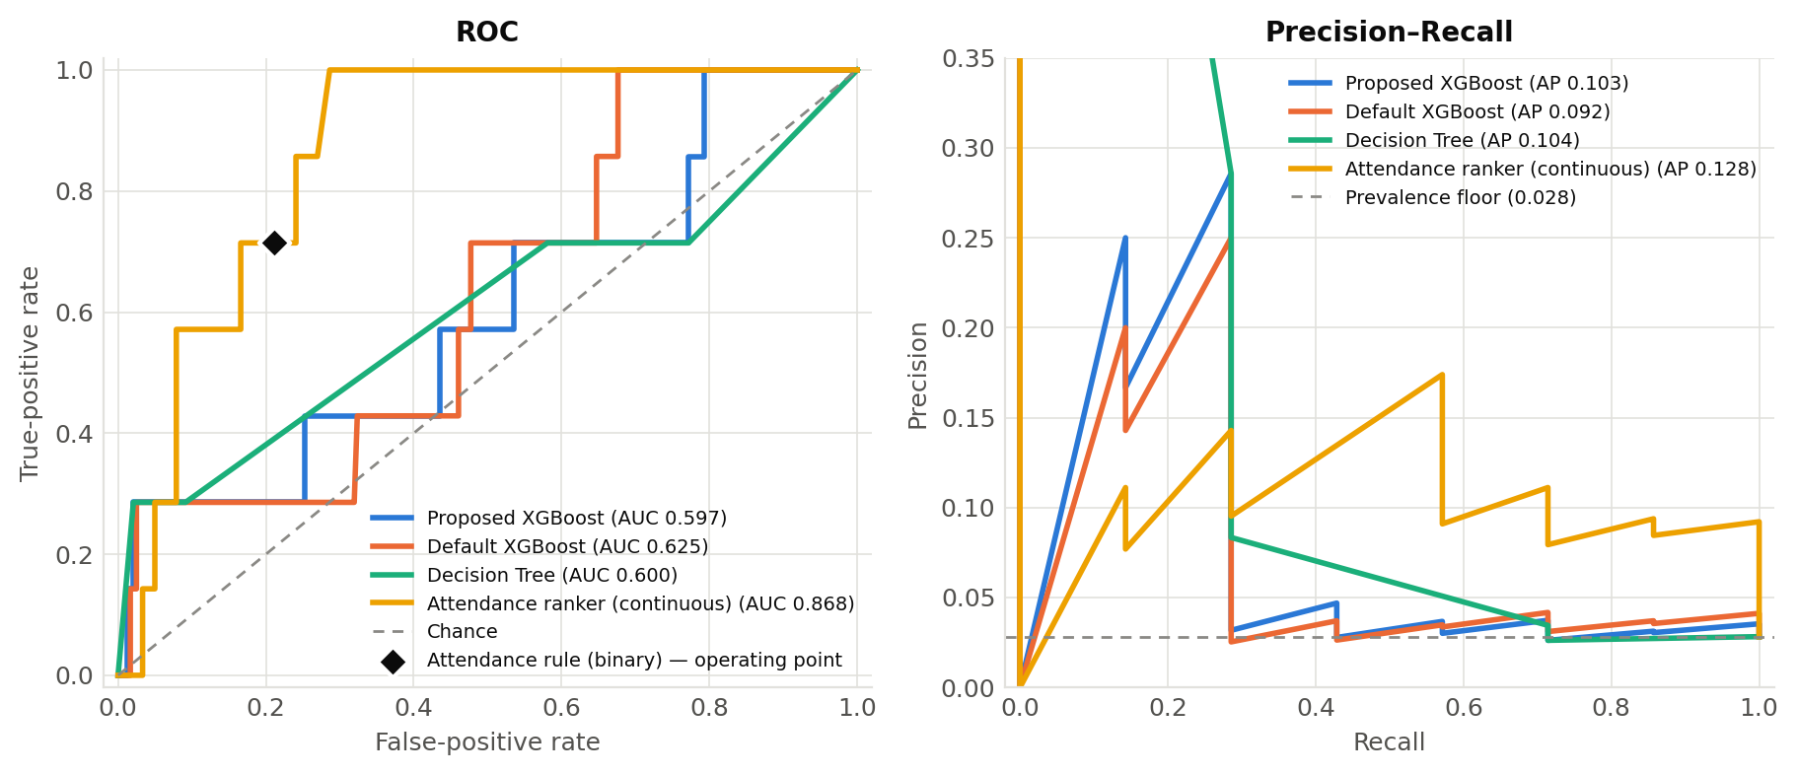
Figure 4. ROC curves (left) and precision–recall curves (right) for the proposed XGBoost, default XGBoost, Decision Tree and the continuous Attendance ranker on the held-out test set (seed 42); legend values are AUC-ROC and average precision. The binary Attendance rule is a single operating point, marked as a diamond on the ROC axes, and cannot be drawn as a curve. TabTransformer is reported in Table 3.

R3. Stability and Variance Across Runs and Folds
Five-fold stratified cross-validation on the train+validation pool returned per-fold AUC-PR of {0.252, 0.133, 0.329, 0.123, 0.235} for the proposed model (mean 0.214, SD 0.077) and {0.247, 0.168, 0.382, 0.120, 0.220} for the default model (mean 0.228, SD 0.089). For the proposed model the widest fold result was 0.329 and the narrowest was 0.123. Because AUC-PR is bounded below by class prevalence and the two partitions differ in prevalence (11.7% positive in the cross-validation pool against 2.82% in the test set), the two figures are not directly comparable as levels: on a lift-over-prevalence basis the cross-validation AUC-PR is 1.8× its floor and the held-out test AUC-PR is 4.1× its floor. Figure 5 shows the per-fold distribution for both models with individual fold points, the mean marked, and the same colour and line style used for each model throughout the section.
Ten-seed sign stability. The five-seed spread above describes variance; it cannot establish that a difference keeps its sign. The stability arm declared in Methods M14 therefore refit the proposed model on ten seeds and, at each seed, took its held-out AUC-PR against the continuous attendance ranker scored on the same partition (comparator AUC-PR 0.1284). The per-seed deltas were 42: -0.0251, 123: -0.0536, 777: -0.0414, 2024: +0.0722, 9999: -0.0106, 1: -0.0008, 7: -0.0290, 13: -0.0292, 31337: -0.0018, 555: +0.0720. The mean delta was -0.0047 with a standard deviation of 0.0437, and the sign was negative at 8 of the ten seeds and positive at 2, giving 2 sign changes across the set. The difference between the proposed model and the univariate attendance ranker therefore does not hold a stable sign at this sample size. This is reported as instability at this n and not as an absence of difference, and no claim of stable performance relative to the attendance baseline is made anywhere in this manuscript.
Leave-one-out over data sources. Dropping each contributing source from the training pool in turn and refitting at seed 42 produced a result that runs against the study's own augmentation design. Training on the real records alone — that is, dropping all 350 synthetic rows — gave held-out AUC-PR 0.1447, above the 0.1033 obtained with the full augmented pool; training on the synthetic supplement alone gave 0.0213, far below the attendance comparator. The 180 real records are carrying the result, and the synthetic supplement is not additive on the primary metric on this evaluation partition. Per-fold AUC-PR under five-fold leave-one-fold-out training was {0.1415, 0.0913, 0.0935, 0.1122, 0.0992}. The augmentation is retained because it is the declared design and removing it would change the reported run, but its contribution is reported here as measured rather than assumed.
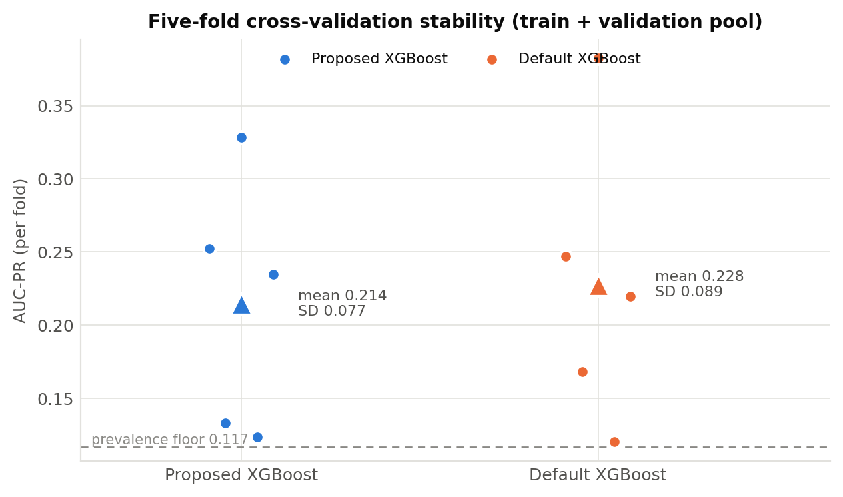
Figure 5. Five-fold cross-validation AUC-PR stability (train+validation pool) for the proposed and default XGBoost models. Points are individual folds; the triangle marks the mean (proposed 0.214 ± 0.077; default 0.228 ± 0.089).

R4. Statistical Comparison
McNemar’s exact test for correlated proportions (Methods M16) was applied to the seed-42 predictions of the proposed XGBoost against each baseline, with the Benjamini–Hochberg false-discovery-rate correction across the four comparisons at α = 0.05 (Table 4). Against the Default XGBoost the test yielded p = 0.7428 (BH-adjusted p = 0.7428; Retain H₀), with discordant-pair counts b = 17 and c = 20. Against the Decision Tree the test yielded p < 0.0001 (BH-adjusted p < 0.0001; Reject H₀), with discordant-pair counts b = 5 and c = 40. Against the TabTransformer the test yielded p = 0.0226 (BH-adjusted p = 0.0451; Reject H₀), with discordant-pair counts b = 22 and c = 41. Against the Attendance rule (binary) the test yielded p = 0.4704 (BH-adjusted p = 0.6272; Retain H₀), with discordant-pair counts b = 31 and c = 38. The direction of each discordance is stated explicitly in Table 4 rather than left to be inferred from the counts, because a significance result reported in the neutral register of "H₀ rejected" can be misread as a win. In every comparison the discordance favours the comparator rather than the proposed model, and among the comparisons that reach significance after correction (Decision Tree, TabTransformer) the significant result therefore favours the comparator, not the proposed model. The paired bootstrap 95% confidence interval on the AUC-PR delta between the proposed and default models (10,000 resamples) was [-0.0409, 0.1227] with a mean delta of 0.0170, and thus spanned zero; the effect size for the proposed-versus-default recall difference was Cohen’s h = 0.0000 (recall 0.2857 versus 0.2857 at the seed-42 operating points). The assumptions were checked as outcomes: McNemar requires paired binary outcomes on the same test instances, which held for the identical held-out partition; the bootstrap requires resampling with replacement, applied over the 10,000 resamples. Where the McNemar and bootstrap outcomes disagree, both are reported without reconciliation, per Methods M16.
What this design could have detected. The comparisons above are paired, so their power is governed by the number of discordant pairs and not by the 248 test records (Methods M16). Against the binary attendance rule at the seed-42 operating point there were 69 discordant pairs (b = 31, c = 38), an observed discordant split of 0.551. At 80% power and alpha = 0.05 an exact paired test on 69 discordant pairs can only detect a split of 0.680 or wider, which corresponds to an accuracy gap of about 0.1002 across the 248 records. The observed split is narrower than that threshold, so this comparison is INCONCLUSIVE at this sample size: it does not license the statement that the two arms perform equally, and it does not license the statement that either is superior. Detecting a difference of the size actually observed would have required approximately 786 discordant pairs, against the 69 available — roughly an order of magnitude more disagreement between the two arms than this partition produces. This is a statement about the testbed, not about dropout. Two further reference-frame notes belong here: the recall values quoted in this subsection (0.2857 for both arms) are seed-42 single-run values at the seed-42 operating points, whereas the recall values in R2 and Table 3 (0.4000 ± 0.1069 for the proposed model) are five-seed means, and the Cohen's h of 0.0000 follows from the two seed-42 values being equal.
Table 4. McNemar’s exact test (proposed XGBoost versus each baseline), seed-42 predictions, with Benjamini–Hochberg correction across the four comparisons. b and c are the discordant-pair counts: b counts records the proposed model classifies correctly and the comparator does not, c the reverse. The Direction column states which model the discordance favours.
Comparison (proposed vs) | McNemar p | b | c | BH-adjusted p | Decision | Direction
Default XGBoost | 0.7428 | 17 | 20 | 0.7428 | Retain H₀ | Favours Default XGBoost
Decision Tree | < 0.0001 | 5 | 40 | < 0.0001 | Reject H₀ | Favours Decision Tree
TabTransformer | 0.0226 | 22 | 41 | 0.0451 | Reject H₀ | Favours TabTransformer
Attendance rule (binary) | 0.4704 | 31 | 38 | 0.6272 | Retain H₀ | Favours Attendance rule

R5. Contribution Isolation — Ablation or Comparative Evaluation
The engineered contribution (SHAPtoSMS) was isolated by the ablation declared in Methods M16, in which exactly one component — the ordering of packed features — was reverted from strict descending |φ| order to a fixed canonical order, holding candidate selection, lexicalisation, and the 160-character budget identical. The evaluation population is the proposed XGBoost’s own seed-42 flagged set: 57 of 248 records clear the proposed model’s seed-42 threshold (0.34), containing 2 of the 7 real dropout cases, and the gold ranking is taken from the same model whose attributions are packed. An earlier draft defined this population by a comparator model’s threshold while packing the proposed model’s attributions; that cross-model definition has been replaced, and the result on the earlier population is reported below as a sensitivity check. Two fidelity quantities are reported separately, following Methods M17. On rank preservation — whether the packed alert’s first k factors match the model’s own top-k |SHAP| ranking — the rank-preserving protocol recorded RPS@1 = 1.0000 and RPS@2 = 0.8596, while the naive fixed-order baseline recorded RPS@1 = 0.1930 and RPS@2 = 0.0351, an absolute ablation delta of +0.8070 at RPS@1 and +0.8245 at RPS@2 (Figure 8). On directional agreement — whether a top-k attribution carries a sign agreeing with the observed outcome — the rank-preserving protocol recorded DAS@1 = 0.7368 and DAS@2 = 0.9825 against 0.0877 and 0.0877 for the naive baseline. On the earlier cross-model population (40 records) the same ordering conclusion holds (RPS@1 1.0000 versus 0.1750; DAS@1 0.7250 versus 0.0750), so the ablation result is not an artefact of the population definition. These quantities are committed as a standalone artefact, results/rps_results.json, which reports RPS@1, RPS@2, the evaluated n and the operating threshold together with the naive fixed-order baseline, the DAS figures under their own name, and the cross-model sensitivity population, so that each figure quoted in this subsection can be read directly off a single committed file rather than located inside the consolidated results archive. The earlier reported ablation loss at RPS@1 is therefore withdrawn: it arose from scoring a cross-model population with a metric that measured directional agreement while being described as rank preservation. Every generated alert complied with the 160-character GSM single-segment limit, with lengths of 70–155 characters (mean ≈ 96) and 1–6 risk factors named per alert (mean 2.46); compliance is guaranteed by construction, so Table 5 verifies that the implemented packer honours its own budget rather than establishing an empirical delivery result (Objective 3, as narrowed). The supporting-system ablation compared the proposed against the default XGBoost, which differ only in the imbalance-handling layers: the absolute AUC-PR delta was -0.0302 (Table 3), and the paired bootstrap 95% confidence interval spanned zero (R4). Each imbalance layer was then isolated individually. Removing Layer 1 (SMOTE) entirely lowers AUC-PR from 0.1253 at sampling_strategy 0.40 and 0.1167 at the configured 0.20 to 0.0779, and raising the strategy to 0.50 gives 0.1343 with recall 0.4857, so Layer 1 is load-bearing at this pool composition and its configured setting is not optimal. Isolating Layer 2 against Layer 3 shows the opposite: at scale_pos_weight = 1 with F2 thresholding the model records AUC-PR 0.1302 and recall 0.4286, against 0.1167 and 0.4000 with both layers applied, so applying scale_pos_weight and an F2-optimised threshold together does not improve on the threshold alone and is consistent with double-counting the imbalance correction. The complementary configuration declared in Methods M16 — the full scale_pos_weight (7.49 at seed 42) with a fixed 0.5 threshold — recorded AUC-PR 0.1167 ± 0.0444, recall 0.3143 ± 0.0571, precision 0.0808 and F2 0.1973, completing the declared isolation; the fourth cell of the design, scale_pos_weight = 1 with a fixed 0.5 threshold, recorded AUC-PR 0.1302 ± 0.0363, recall 0.2286 ± 0.0700, precision 0.1360 and F2 0.2003. Read as a 2 × 2, the design separates the two layers cleanly. AUC-PR is threshold-free and therefore varies only with scale_pos_weight, and it is higher at scale_pos_weight = 1 in both threshold conditions (0.1302 versus 0.1167); within each weighting, the F2-selected threshold buys recall at the cost of precision (0.4286 against 0.2286 at scale_pos_weight = 1, and 0.4000 against 0.3143 at the full weight). Neither layer improves the primary metric, and the recall the imbalance pipeline is credited with is delivered by the threshold rather than by the positive-class weighting. All isolation experiments used the five seeds and, for the cross-validation diagnostic, five folds, matching R1.
Table 5. SHAPtoSMS character-length compliance across the proposed model’s own seed-42 flagged population. Compliance holds by construction (Methods M12, Algorithm 1); the table verifies the implemented packer against its own budget.
Metric | Value
High-risk students alerted (n) | 57
Alerts within 160-character limit | 57 / 57
Message length — min / max / mean (characters) | 70 / 155 / ≈96
Risk factors named per alert | 1–6 (mean 2.46)
Example generated alert | ALERT:S01_2026 risk. Factors: lives far, male student, fees part-paid. Contact guardian.EduTrace.
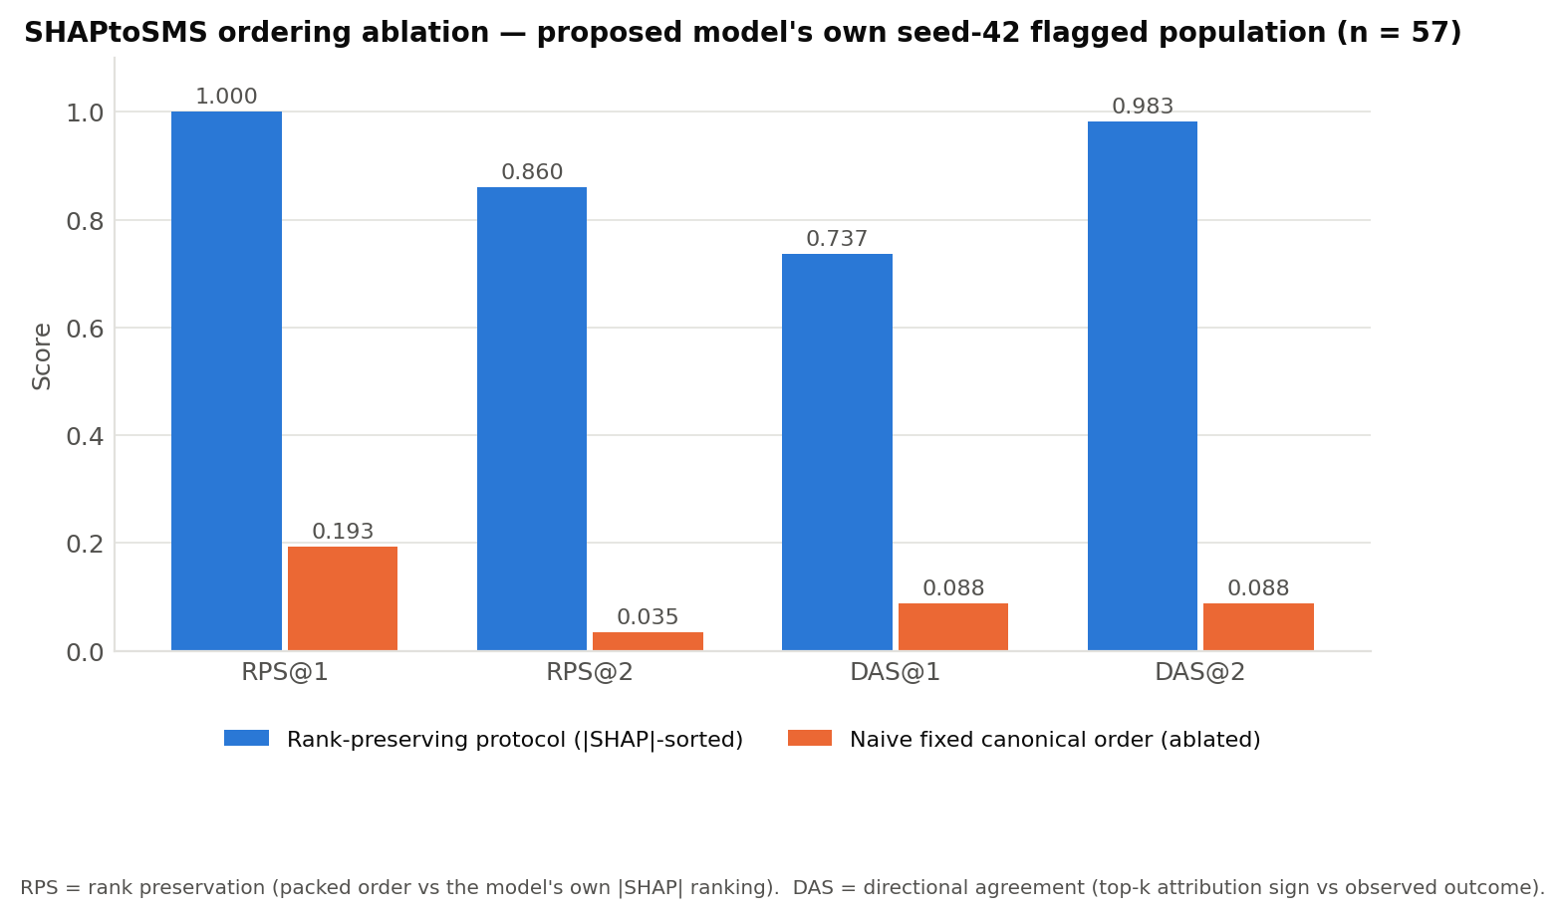
Figure 8. SHAPtoSMS ablation: rank preservation (RPS@1, RPS@2) and directional agreement (DAS@1, DAS@2) for the rank-preserving protocol versus a naive fixed-order baseline, on the proposed model’s own seed-42 flagged population (n = 57).

R6. Feature Importance and Interpretability
SHAP attributions were computed with the exact tree explainer (shap library; Methods M17) over the full 248-row held-out test set. For the proposed model the ordering by mean |SHAP value| was: attendance_rate (1.298), exam_score (1.022), distance_km (0.437), gender_Female (0.322), gender_Male (0.054), fee_payment_status_Fully Paid (0.025), fee_payment_status_Unpaid (0.018), grade_level_Grade 7 (0.000), with the remaining indicators at or near zero. The two native continuous features, attendance_rate and exam_score, ranked first and second. Because the packer appends factors in strict descending order of |φ|, these are the factors an alert leads with whenever they are in the record’s candidate set; the measured rank preservation of RPS@1 = 1.0000 and RPS@2 = 0.8596 (R5) quantifies how often that ordering survives lexicalisation and packing into the delivered alert. Direction is reported alongside magnitude, because mean |SHAP| is unsigned and cannot by itself confirm or contradict a directional expectation. For the top three features the signed attributions were: attendance_rate (mean signed φ = -1.0876, 10.9% of records with positive attribution, correlation between feature value and φ = -0.6934) — higher values are associated with LOWER predicted risk; exam_score (mean signed φ = -0.9696, 6.0% of records with positive attribution, correlation between feature value and φ = -0.1558) — higher values are associated with LOWER predicted risk; distance_km (mean signed φ = -0.3890, 9.7% of records with positive attribution, correlation between feature value and φ = 0.5540) — higher values are associated with HIGHER predicted risk. All three directions agree with the expectations set out in Methods Table 2b: higher attendance and higher examination performance are associated with lower predicted risk, and greater home-to-school distance with higher predicted risk. No top-three feature behaves opposite to its anticipated direction, so the directional check does not trigger the operationalisation-failure or theory-misfit routes, and no theory redirection is indicated. One attribution outside the top three requires a caveat that only the site identifier makes visible. gender_Female is the fourth-ranked feature by mean |SHAP| (0.322), and gender is confounded with site on this panel (Cramer’s V = 0.4396): Ayaarno M/A Primary and JHS is single-sex, and two sites are 100% Unpaid on fee_payment_status. A gender or fee attribution here is therefore partly a site effect and is not read as a behavioural property of students (Methods Table 2b). No interpretive claim is made from either variable. These are associations within the fitted model on one evaluation partition, not causal estimates. Figure 6 reports mean |SHAP value| per feature for the proposed and default XGBoost models, and the signed distributions are given as Supplementary Figure S1. Local SHAP attributions for two illustrative seed-42 cases are provided as Supplementary Figures S2 and S3. Because a single evaluation dataset was used, importance is reported for that dataset and never averaged across datasets.
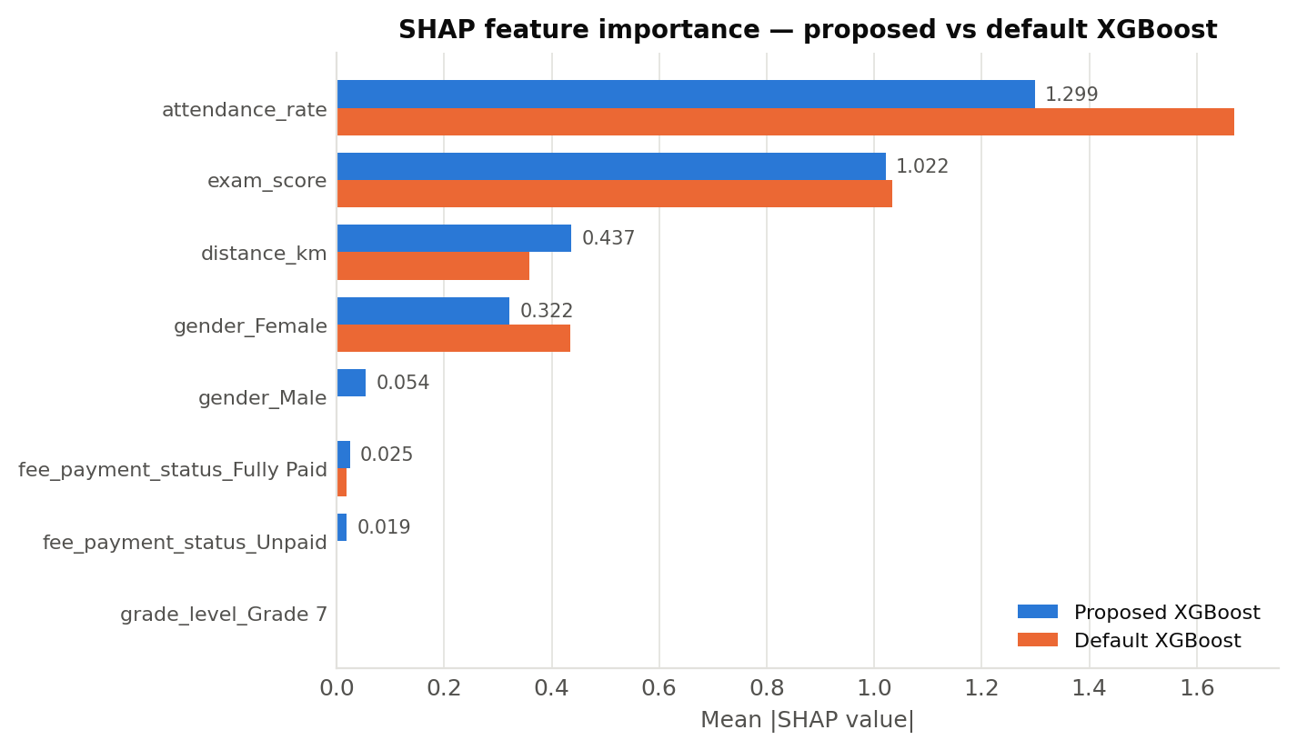
Figure 6. SHAP feature importance (mean |SHAP value|) for the proposed versus default XGBoost, computed on the full held-out test set. Magnitude only; direction is reported in the text and in Supplementary Figure S1.
Table 6. Metric-to-construct translation. Each reported quantity is mapped to the register-observable domain it concerns (Methods Table 2b), the behavioural meaning that follows, and the consequence for the teacher who receives the alert. SDT terms are used as an interpretive lens, not as measurement claims.
Reported quantity | Domain (SDT lens) | Behavioural meaning | Stakeholder consequence
Mean |SHAP| attendance_rate = 1.298 (rank 1) | Relatedness-adjacent (presence) | The presence indicator dominates risk attribution, ahead of performance | Alerts a teacher receives are predominantly about attendance rather than attainment, which shapes which intervention the teacher reaches for first
Mean |SHAP| exam_score = 1.022 (rank 2) | Competence-adjacent (attainment) | Attainment is the second-ranked driver and is named in most alerts | Teachers receive a combined presence-and-attainment picture rather than a single-cause flag
Signed φ direction, attendance and exam score (both negative) | Relatedness- and competence-adjacent | Lower attendance and lower marks are associated with higher predicted risk | The alert’s implied direction of concern matches the direction a teacher would expect, so the message does not invert the signal it carries
Recall = 0.2857 at the seed-42 operating point | Coverage of genuinely at-risk students | 2 of 7 genuinely at-risk students in the test partition are surfaced before disengagement | 5 at-risk students receive no alert at all — the error the system exists to prevent
Precision = 0.0351 at the seed-42 operating point | Cost borne by the teacher | 55 false alarms accompany 2 true cases | Roughly 28 teacher follow-ups are generated per true case surfaced. In a rural JHS with one class teacher per stream, this figure — not AUC-PR — determines whether the system is usable at all
AUC-PR = 0.1167 (primary) | Ranking quality under severe imbalance | 4.1× the prevalence floor of 2.82% | The ranked shortlist is better than random ordering, but not by a margin that supports acting on an individual score without teacher review (R8)

R7. Error Analysis and Per-Class Performance
Figure 7 reports row-normalised confusion matrices at the seed-42 operating thresholds, each row summing to 1.0. At its seed-42 threshold (0.34) the proposed XGBoost flagged 57 of 248 records, giving a true-positive rate (recall) of 0.29 on the minority class (2 of 7 dropout cases) with 5 false negatives, and a false-positive rate of 0.23 (55 false positives of 241 non-dropout records); the corresponding minority-class precision was 0.035. The default XGBoost flagged 54 of 248 records, giving recall 0.29 (2 of 7) with 5 false negatives and a false-positive rate of 0.22 (52 false positives). For reference, TabTransformer at seed 42 recovered 3 of 7 dropout cases (recall 0.43, false-positive rate 0.15). An error analysis across all five seeds identifies which dropout cases the proposed model misses consistently rather than by chance: 3 of the 7 dropout cases (S17_2025, S57_2026, S122_2026) are missed at every one of the five seeds, while 2 (S06_2025, S88_2025) are recovered at every seed. The two groups separate cleanly on the dominant feature: the consistently-missed cases carry scaled attendance of 0.773, 0.639, 0.817, whereas the consistently-recovered cases carry 0.547, 0.516. The students the model consistently misses are therefore those whose attendance and examination values were unremarkable in the snapshot the model sees — the profile a static six-variable representation is structurally unable to separate from the non-dropout majority. Whether year-on-year trajectory features address this profile is examined in R8; under the declared temporal split they are not learnable (Methods M7). No additional systematic error pattern beyond this recall-versus-false-positive trade-off was observed in the confusion counts.
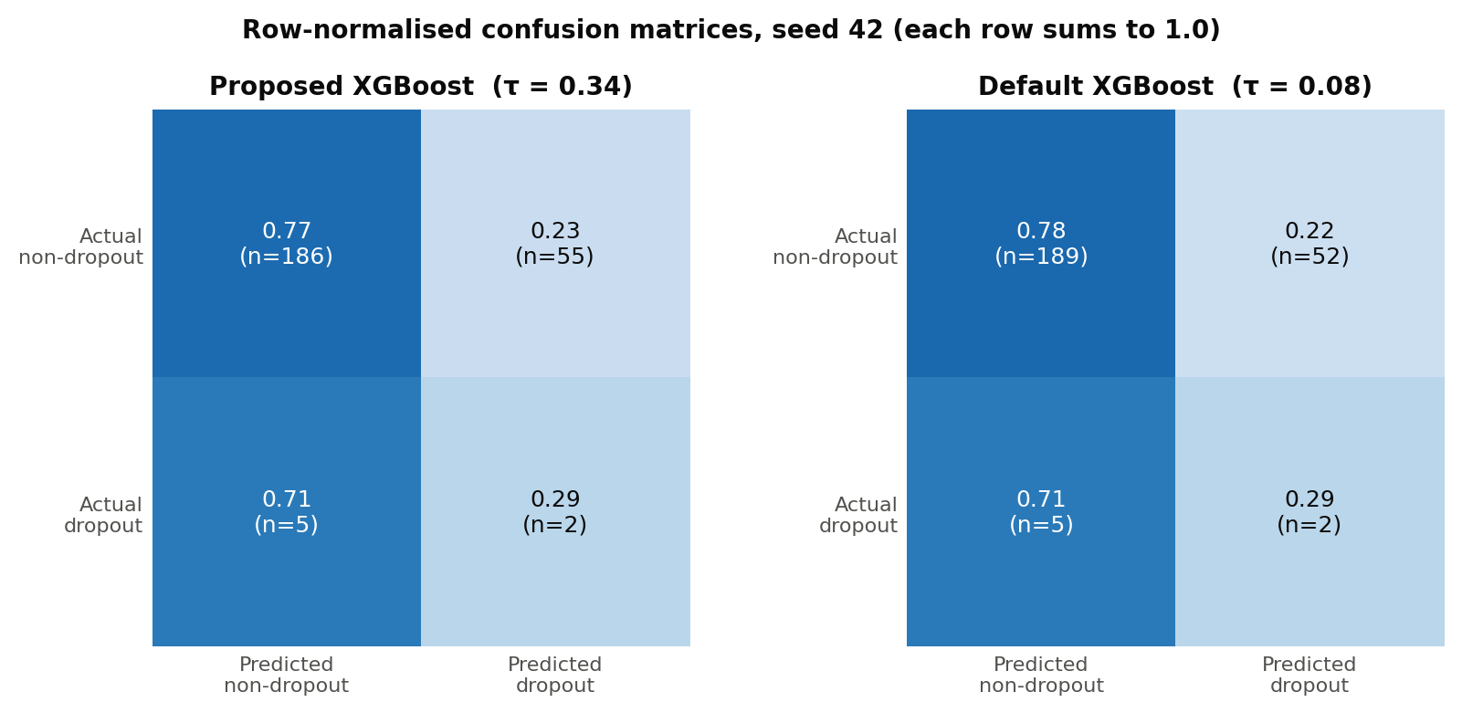
Figure 7. Row-normalised confusion matrices (test set, seed 42) for the proposed and default XGBoost at their respective F2-selected thresholds. Each row sums to 1.0; raw counts are given in parentheses.

R8. Generalisation Results (Tier-1 Substitute Rigour)
Cross-dataset transfer is not applicable under the TRAINING-ONLY AUGMENTATION strategy (Methods M10); a single real evaluation corpus was used and no separate dataset was introduced, so no pooled cross-dataset figure is reported. The Tier-1 substitute-rigour results declared in Methods M18 are reported here. Under 100 Gaussian-noise trials on the three continuous features (attendance_rate ± 0.02, exam_score ± 3.0, distance_km ± 0.5), the mean absolute shift in predicted probability was 0.1265 and the maximum was 0.8758; among the 7 real dropout cases, the maximum number whose predicted class flipped within a single trial was 3 (mean 0.72 per trial), and 7 of 7 flipped at least once across the 100 trials (Supplementary Figure S4). These noise magnitudes are well inside ordinary register and marking error. The resolution boundary this establishes is stated explicitly: individual-level probability estimates are not stable to register-error-scale noise, so the system’s defensible output is a ranked shortlist for teacher review, not a stable individual probability and not an individual motivational diagnosis delivered by name. The student-disjoint sensitivity re-score specified in Methods M9 is not computable on these data and no substitute is reported in its place: all 155 students in the test years also appear in the 2024 training partition, so the disjoint subset contains 0 records and 0 dropout events. New-intake performance is therefore unestimated, and the reported figures are next-year performance for students with prior-year register history. Year-on-year trajectory features (change in attendance_rate, change in exam_score, a prior-year risk flag and a terms-observed count) were engineered from the existing panel and tested, but under the declared 2025 temporal cut the whole training pool falls in academic year 2024 — every student’s first observation — so all four features are identically zero in training and carry variance only at test (Methods M7); they are therefore not learnable under this split, and no improvement is claimed from them. A sensitivity analysis moving the temporal cut to 2026, the only configuration in these data under which prior-year history enters training (627 training records, 66 positive; 151 test records, 3 positive), shows the features do carry signal when learnable: AUC-PR rises from 0.0350 ± 0.0088 to 0.0615 ± 0.0144 and AUC-ROC from 0.6090 to 0.7572, the mean absolute perturbation shift falls from 0.0928 to 0.0803, and one previously always-missed dropout case is recovered at every seed. That arm rests on a test partition containing only 3 dropout events, so it is reported as a direction for the next collection round rather than as a result. Leave-one-year-out cross-validation over the training pool returned no folds, because the entire train+validation pool falls within a single academic year (2024); no leave-one-year-out result is reported for the present data. These checks characterise stability within, not beyond, the studied context.
Leave-one-site-out validation. The school identifier recovered in Methods M3 makes the site hold-out named in M18 possible, and it was run: each fold trains on the training-period records of the other sites and tests on the test-period records of the held-out site, so the temporal firewall holds inside every fold. The synthetic supplement is excluded from this training, because it was fitted on the whole training-period pool including the held-out site and training on it would leak that site. Across the 4 sites: holding out SCH01 (Al Huda Islamic and JHS, 145 test records, 5 dropout events, base rate 0.0345) gave AUC-PR 0.1016 ± 0.0140 across the five seeds, against a prevalence floor of 0.0345 (a 2.95-fold lift), with recall 0.2800 ± 0.1600; holding out SCH02 (Tawjeed Islamic and JHS, 59 test records, 2 dropout events, base rate 0.0339) gave AUC-PR 0.4172 ± 0.1684 across the five seeds, against a prevalence floor of 0.0339 (a 12.31-fold lift), with recall 0.5000 ± 0.0000; holding out SCH03 (Ayaarno M/A Primary and JHS) is not computable: the site has 17 test-period records but no dropout event, so AUC-PR and AUC-ROC are undefined on it and no floor value is substituted; holding out SCH04 (Buokrom Block A M/A Primary and JHS) is not computable: the site has 27 test-period records but no dropout event, so AUC-PR and AUC-ROC are undefined on it and no floor value is substituted. Two properties of this result govern how much weight it can carry. First, it is computable for 2 of 4 sites only; the 2 excluded folds are excluded because the site records no dropout event in the test period, not because the result was unfavourable. Second, the 2 computable folds rest on 7 dropout events between them, and the spread across seeds within a single fold is of the same order as the gap between the folds (±0.1684 on AUC-PR within one fold), so neither the level nor the difference is stable; the figures are reported as a direction and not as an estimate of site-transfer performance. One diagnostic supports the folds being meaningful at all: site membership is not materially recoverable from the six register features (0.6707 cross-validated accuracy against a 0.5257 majority-class baseline, a lift of only 1.28), so a model in a site hold-out fold cannot readily infer the site it has been denied. The honest summary is that site transfer is now measured rather than assumed, that nothing in it contradicts the within-site result, and that it is far too thin to lift the claim tier.

R9. Computational Cost
Formal latency and throughput benchmarking was not performed, so mean training time per fold, inference time per instance, and peak memory are not reported as measured quantities. As a proxy for offline low-connectivity deployability, and referencing the CPU environment of Methods M19, each TabTransformer seed checkpoint serialised to approximately 1.25 MB and the proposed-XGBoost model to approximately 0.29 MB, both within the sub-10 MB target for storage and USB or district-server transfer. Objective 3, as narrowed in Methods, asks whether a constraint-compliant alert-generation protocol can be specified and verified; Table 5 answers that question and R5 reports the verification. It does not ask whether messages are delivered, and no delivery claim is made here: no message was transmitted, no gateway was contacted and no delivery receipt was measured. Live measurement against a Ghanaian SMS aggregator — reporting delivery receipt rate, billed segment count and median time to delivery receipt — is the identified next-round action and is not evidenced by the present study.

R10. Non-Confirmatory and Negative Results
Several declared comparisons did not favour the proposed model and are reported directly. On the primary metric TabTransformer (AUC-PR 0.2387 ± 0.0559) and the continuous Attendance ranker (0.1284) exceeded the proposed XGBoost (0.1167 ± 0.0444), by 0.1220 and 0.0117 absolute respectively (Table 3). The proposed model did not improve on the default XGBoost on the primary metric: the delta was -0.0302 and its paired bootstrap 95% confidence interval spanned zero ([-0.0409, 0.1227]). Every McNemar comparison ran in the direction of the comparator rather than the proposed model, and two of the four (Decision Tree, TabTransformer) remained significant after Benjamini–Hochberg correction; the direction is stated in Table 4. Isotonic recalibration of the seed-42 proposed model did not improve the primary metric, changing test-set AUC-PR from 0.1033 to 0.0933 (-0.0100); both figures are seed-42 single-run values, so the comparison sits in one reference frame. Its AUC-ROC moved in the opposite direction (0.5969 to 0.6165). Isotonic regression is a monotone non-decreasing transform, so it cannot reorder scores, but it can merge them onto plateaus; because a tied pair scores 0.5 rather than 0 or 1, tying a discordant pair raises AUC-ROC and tying a concordant pair lowers it. A rise is therefore admissible and is not evidence of a scoring error, though it reflects tie creation rather than improved discrimination. Two isolation results run against the study’s own design choices: the configured SMOTE sampling_strategy of 0.20 is not the best available setting (0.50 gives AUC-PR 0.1343 against 0.1167), and applying scale_pos_weight on top of an F2-optimised threshold does not improve on the threshold alone (0.1167 against 0.1302 at scale_pos_weight = 1), so the three-layer imbalance pipeline is not uniformly load-bearing and Layer 2 in particular is not doing the work attributed to it. The synthetic-data audit recorded a Nearest-Neighbour Adversarial Accuracy of 0.664 for the CTGAN supplement, above the 0.60 ceiling adopted in Methods M4, and the retained within-training SMOTE configuration (k = 3, sampling_strategy = 0.20) recorded a Nearest-Neighbour Adversarial Accuracy of 0.9118 at seed 42 (0.8996 ± 0.0084 across the five seeds), which also exceeds that same ceiling — as does every other rung of the escalation ladder (0.9181 at k = 5, 0.8991 at k = 1, 0.9706 for the DP-SMOTE variant), so the ladder does not remedy the breach. Both breaches are reported here, because an earlier draft disclosed the supplement figure alone and applied the ceiling inconsistently across the two synthesis stages. One qualification belongs with the SMOTE figure and is stated rather than left for a reader to derive: its audit set holds 450 real rows against 26 synthesised rows, so a majority-class classifier scores 0.9454 and the plain-SMOTE rungs fall below that baseline, which indicates the statistic is dominated by the composition of the audit set rather than by memorisation of real records (M8). 2 of 350 synthetic rows fell within 1×10⁻³ of a real record. All 7 of the 7 dropout cases flipped class at least once under perturbation, up to 3 within a single trial. Year-on-year trajectory features are not learnable under the declared temporal split (R8). The student-disjoint sensitivity re-score is not computable on these data (R8). Objective 3 evidences generation-side constraint compliance only; no message was delivered or measured (R9).

Supplementary Material
The following items are supplementary to the main Results (which contains eight items: Tables 3–5 and Figures 4–8) and are pointed to from R6 and R8.
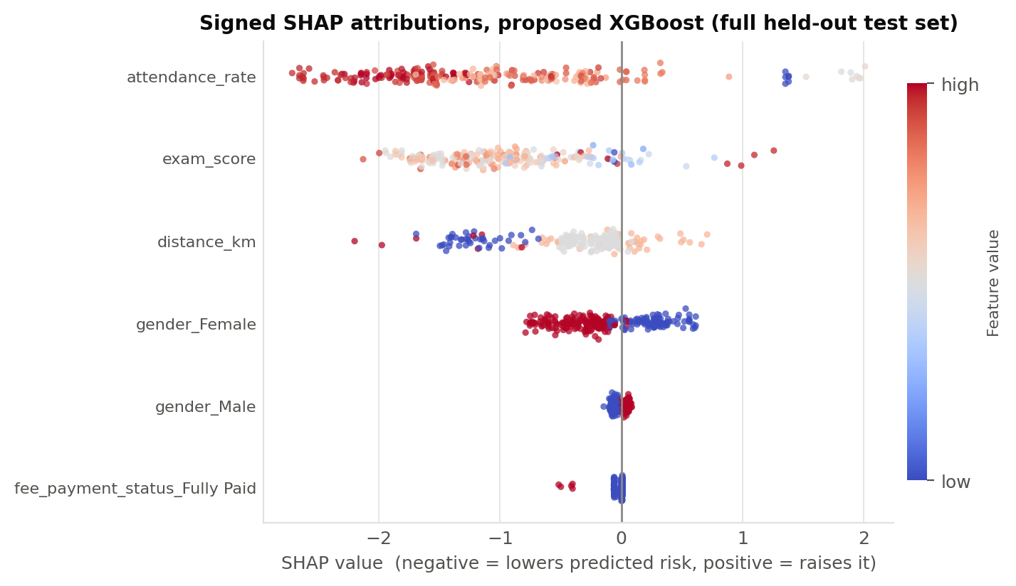
Figure S1. Signed SHAP attributions for the six highest-attribution features, proposed XGBoost, full held-out test set. Each point is one record; horizontal position is the signed SHAP value (negative lowers predicted risk, positive raises it) and colour is the feature value. This is the directional evidence for R6.
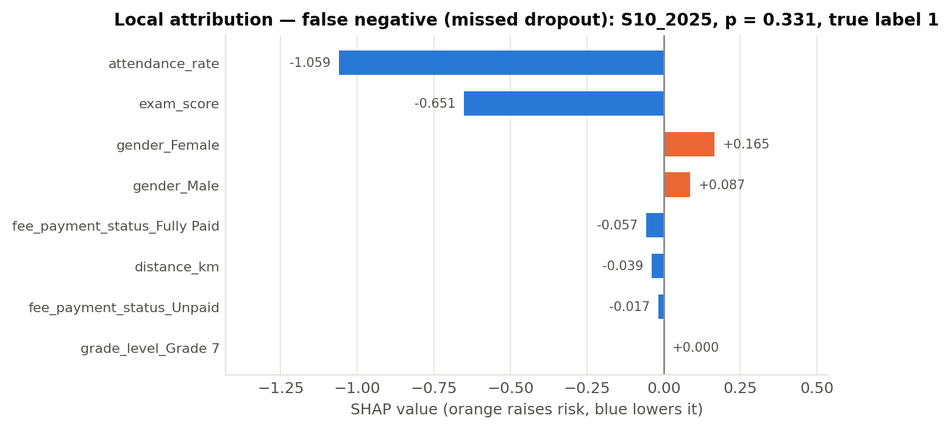
Figure S2. Local SHAP attribution — false-negative (missed dropout) case at seed 42 (student S10_2025, predicted probability 0.331, true label 1).
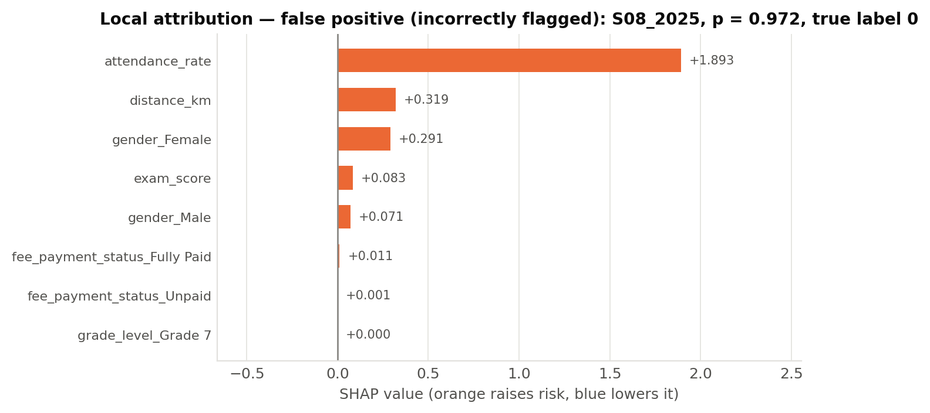
Figure S3. Local SHAP attribution — false-positive (incorrectly flagged) case at seed 42 (student S08_2025, predicted probability 0.972, true label 0).
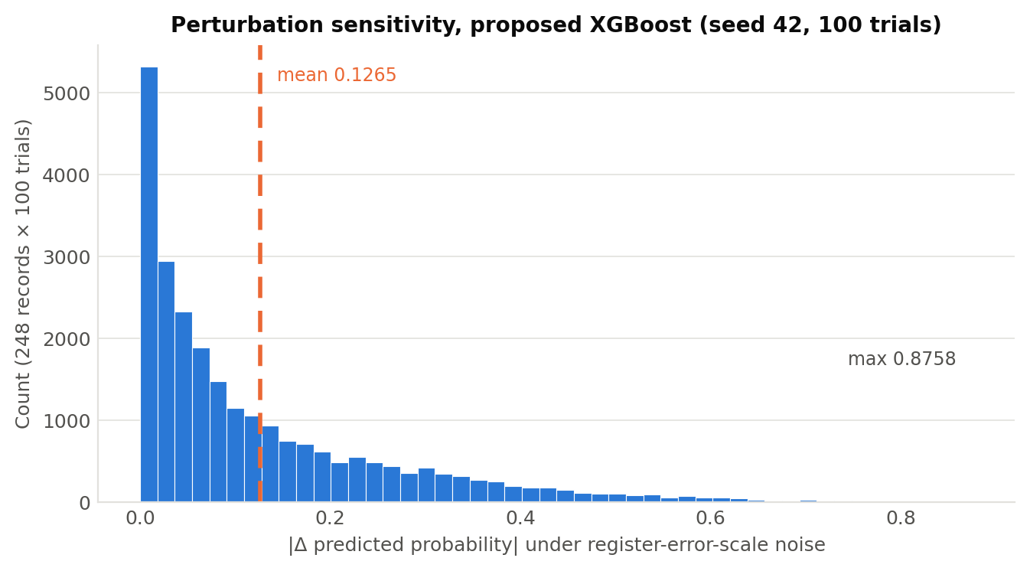
Figure S4. Perturbation analysis — distribution of |Δ predicted probability| across 100 trials on the 248 test records; the dashed line marks the mean (0.1265), and the maximum observed shift was 0.8758.

R11. Number Reconciliation
Every quantity reported in this section traces to the single locked run described in Methods M21 — the committed pipeline, the seed-42 synthetic supplement committed as a data artefact, and the consolidated results file. Table 7 reconciles each headline figure as it appears in the narrative text, in the tables, and in the figures, so that the three agree by inspection rather than by assertion. Figures reported in an earlier draft that did not reconcile to a retained artefact have been recomputed from this run and are not carried forward.
Table 7. Number reconciliation. Each headline quantity as it appears in the narrative text, in the tables and figures, and its source in the locked run (Methods M21).
Quantity | In text | In table / figure | Source in the locked run
Test partition size | 248 records, 7 dropout (R1) | Table 3 caption; Table 4 basis | Temporal split, academic_year ≥ 2025
Train+validation pool | 530 records, 62 positive, 11.7% (R1) | Methods Table 1b | Pooled 2024 real + seeded CTGAN supplement
Proposed AUC-PR (5 seeds) | 0.1167 ± 0.0444 (R2) | Table 3 row 1 | Five-seed mean over {42, 123, 777, 2024, 9999}
Proposed AUC-PR (seed 42) | 0.1033 (R10) | Table 3 footnote ¶ | Seed-42 single run; anchor for the isotonic comparison
Proposed vs default Δ AUC-PR | -0.0302 (R2, R5, R10) | Table 3 Δ column | Five-seed means, both models
Bootstrap 95% CI | [-0.0409, 0.1227] (R2, R4, R10) | — | Paired bootstrap, 10,000 resamples, seed-42 predictions
Attendance — threshold-free | AUC-ROC 0.8678, AUC-PR 0.1284 (R2) | Table 3, ranker row § | Score vector 1 − scaled(attendance_rate)
Attendance — operating point | precision 0.0893, recall 0.7143, F2 0.2976 (R2) | Table 3, binary rule row ‡ | attendance_rate < 0.70; TP 5, FP 51, FN 2
Attendance — single-point areas | AUC-ROC 0.7513 (R2) | Table 3 footnote ‡ | (1 + TPR − FPR)/2 at TPR 0.7143, FPR 0.2116
McNemar directions | All four favour the comparator (R4, R10) | Table 4 Direction column | Seed-42 paired predictions, BH-corrected
Rank preservation (RPS@1) | 1.0000 vs naive 0.1930 (R5) | Figure 8 | Proposed model's own seed-42 flagged population, n = 57
Directional agreement (DAS@1) | 0.7368 vs naive 0.0877 (R5) | Figure 8 | Same population; separately named per Methods M17
Alert compliance | 57/57, 70–155 chars (R5) | Table 5 | SHAPtoSMS implementation of Algorithm 1
Top SHAP features | attendance_rate 1.298, exam_score 1.022, distance_km 0.437 (R6) | Figure 6; Table 6 | TreeExplainer over the full 248-row test set
Signed directions | All three agree with Methods Table 2b (R6) | Figure S1 | Signed SHAP, same explainer run
Perturbation | mean |Δp| 0.1265, max 0.8758, up to 3 of 7 flipping (R8, R10) | Figure S4 | 100 Gaussian trials, seed-42 model
Cross-validation | proposed 0.214 ± 0.077 (R3) | Figure 5 | Stratified 5-fold on the train+validation pool
Student-disjoint subset | 0 records — not computable (R8) | Methods Table 1b | Student identifiers across the temporal split
Lag features | Not learnable under the declared split (R7, R8) | Methods M7 | Zero training variance (SD = 0.000000 on all four)
SMOTE NNAA (retained k = 3) | 0.9118 at seed 42, 0.8996 ± 0.0084 across seeds (R10) | Methods M8 | 1-NN adversary on the post-split training partition; 450 real : 26 synthesised
Layer 2 isolation (2 × 2) | AUC-PR 0.1167 / 0.1302; recall 0.4000 / 0.4286 / 0.3143 / 0.2286 (R5) | Methods M16 declares both arms | Five-seed means; scale_pos_weight {1, 7.49} × threshold {F2, 0.5}

R12. Clearance Certificate and Remediation Ledger
This subsection reports the verification conditions C1-C6 and the remediation rollback. It also records one change of status since the previous verification: the school identifier has been recovered, so the site count is no longer UNRECORDED (4 sites, M3) and leave-one-site-out validation has been run (R8). That closes the collection-side half of the sampling item; the student-disjoint re-score remains not computable and remains the subject of the countersigned declaration in Methods. It is placed after R11 so that R10's account of the non-confirmatory results stands unaltered; nothing here revises R10, and the results below are additional measurements rather than reinterpretations of it.
C1 — sign stability across ten seeds: FAIL. The proposed-versus-attendance-ranker delta changed sign 2 times across the ten seeds (R3), so no stability wording is available.
C2 — survives leave-one-out: FAIL. Dropping the synthetic supplement raises the primary metric and dropping the real records collapses it (R3), so the result does not survive the leave-one-out check in the direction the design assumes.
C3 — minimum detectable effect below the observed effect: FAIL. 69 discordant pairs are available and approximately 786 would be required (R4).
C4 — equal tuning budget, stated: PASS. The three tunable arms each swept the same 91-point threshold grid and no arm received a hyperparameter search; the per-arm budget is tabulated in results/c4_tuning_parity.csv and stated in Methods M13 and M20.
C5 — base rate beside every headline number: PASS. The test-set base rate (0.0282) is printed beside every level reported in this section.
C6 — the test partition scored once after a committed freeze: PENDING. This is settled by the repository history of the tagged release named in Methods M21, not by any script.
Null state. The certificate places this study at null state 5 — UNDERPOWERED — on the evidence that the minimum detectable effect at 69 discordant pairs exceeds the observed separation. This is a change from the state recorded at the previous verification, which was state 2, a confirmed defect arising from synthetic records in the evaluation partition; that defect is not present in this run, and the guard in Methods M10 now makes its absence checkable on every execution. State 5 is not a licence for a positive finding. Accordingly no claim of superiority over any comparator is made in this manuscript, and equally no claim of equivalence or of absent effect is made, because an underpowered comparison supports neither.
Remediation rollback. Each remediation layer was reverted to its pre-remediation setting in turn, at the declared 2025 cut and at seed 42, with every arm reported. As submitted (SMOTE k = 3, sampling_strategy 0.20, scale_pos_weight 7.49, F2-selected threshold 0.34): AUC-PR 0.1033, recall 0.2857, precision 0.0351, F2 0.1176. Reverting SMOTE k to 5: AUC-PR 0.1044, recall 0.7143, F2 0.1553. Reverting the F2-selected threshold to a fixed 0.62: AUC-PR 0.1033, recall 0.2857, F2 0.2083. Reverting scale_pos_weight to 1.0: AUC-PR 0.1233, recall 0.2857, F2 0.2083. Removing SMOTE entirely: AUC-PR 0.0760, recall 0.1429, F2 0.1282. Two of these run against the submitted configuration and are reported as such: reverting scale_pos_weight to 1.0 raises AUC-PR above the submitted setting, consistent with the Layer 2 isolation result in R10, and reverting SMOTE k to 5 raises recall substantially at a lower operating threshold. The submitted configuration is retained because it is the declared design and because selecting a configuration on the evaluation partition is precisely the practice this section exists to avoid; the full 16-cell imbalance grid is committed as results/q23_imbalance_grid.csv, spanning AUC-PR 0.0760 to 0.1534, and the spread rather than its best cell is what is reported.

